**Industrial Internship Report on**

**”Music Player Application - Malang”**

**Prepared by**

**[Anjali Verma]**

|  |
| --- |
| *Executive Summary* |
| This report provides details of the Industrial Internship provided by upskill Campus and The IoT Academy in collaboration with Industrial Partner UniConverge Technologies Pvt Ltd (UCT).  This internship was focused on a project/problem statement provided by UCT. We had to finish the project including the report in 6 weeks’ time.  My project was creating music player application.  This internship gave me a very good opportunity to get exposure to Industrial problems and design/implement solution for that. It was an overall great experience to have this internship. |

Submitted By :- Submitted To:-

Name - Anjali Verma upSkill Campus

Email-id – anzy9997@gmail.com

Submission Date – 12-07-2023

**TABLE OF CONTENTS**

1 Preface 3

2 Introduction 5

2.1 About UniConverge Technologies Pvt Ltd 5

2.2 About upskill Campus 10

3 Proposed Design/ Model 13

4 Performance Test 16

4.1 About Music Player Application……………......………………….……………….16

4.2 Test Plan/ Test Cases 17

4.3 Test Procedure 17

4.4 Performance Outcome…………………………………………………………………18

5 Problem Statement 19

6 Existing and Proposed solution 20

7 My learnings 21

8 Future work scope 22

9 References…….……..…………………………………………………………………….23

# Preface

My internship started from 1st June as Core Java Intern. I started by choosing project given from several projects. I started working on my music player application for which I done several research how to create it on Google and Youtube. After research I choose programming language by using which I want to create project and I decided by choosing basic web technology like HTML, CSS and Javascript. From then on I’m regularly working on my project for 6 weeks.

My project is music player application which is named Malang which is created using basic web based technologies like HTML, CSS and Javascript. As it is self-paced internship I learned so much on my own in this 6 weeks program.

I need this internship for my compulsory internship of 45 days for my degree course.I’m thankful for upskill campus to provide this opportunity to me. It helped me to understand how project is created and problems are solved in real world.

How Program was planned



I learned so much throughout this internship. I get to know how websites are designed, how user interface is most important part of any application, how different programming languages can be used to create websites, how there’s different technologies available for front-end and back-end development, how different sources are available to provide knowledge according to our need. Most important I learned there’s always solution for every problem.

Thanks to upSkill campus, The IoT academy and uct for providing this free internship opportunity. It helped me a lot to get experience in project development and problem solving.

# Introduction

## About UniConverge Technologies Pvt Ltd

A company established in 2013 and working in Digital Transformation domain and providing Industrial solutions with prime focus on sustainability and RoI.

For developing its products and solutions it is leveraging various**Cutting Edge Technologies e.g. Internet of Things (IoT), Cyber Security, Cloud computing (AWS, Azure), Machine Learning, Communication Technologies (4G/5G/LoRaWAN), Java Full Stack, Python, Front end**etc.



1. UCT IoT Platform**(****)**

**UCT Insight** is an IOT platform designed for quick deployment of IOT applications on the same time providing valuable “insight” for your process/business. It has been built in Java for backend and ReactJS for Front end. It has support for MySQL and various NoSql Databases.

* It enables device connectivity via industry standard IoT protocols - MQTT, CoAP, HTTP, Modbus TCP, OPC UA
* It supports both cloud and on-premises deployments.

It has features to  
• Build Your own dashboard  
• Analytics and Reporting  
• Alert and Notification  
• Integration with third party application(Power BI, SAP, ERP)  
• Rule Engine



1. **Smart Factory Platform (****)**

Factory watch is a platform for smart factory needs.

It provides Users/ Factory

* with a scalable solution for their Production and asset monitoring
* OEE and predictive maintenance solution scaling up to digital twin for your assets.
* to unleased the true potential of the data that their machines are generating and helps to identify the KPIs and also improve them.
* A modular architecture that allows users to choose the service that they what to start and then can scale to more complex solutions as per their demands.

Its unique SaaS model helps users to save time, cost and money.



1. based Solution

UCT is one of the early adopters of LoRAWAN teschnology and providing solution in Agritech, Smart cities, Industrial Monitoring, Smart Street Light, Smart Water/ Gas/ Electricity metering solutions etc.

1. Predictive Maintenance

UCT isproviding Industrial Machine health monitoring and Predictive maintenance solution leveraging Embedded system, Industrial IoT and Machine Learning Technologies by finding Remaining useful life time of various Machines used in production process.



## About upskill Campus (USC)

upskill Campus along with The IoT Academy and in association with Uniconverge technologies has facilitated the smooth execution of the complete internship process.

USC is a career development platform that delivers **personalized executive coaching** in a more affordable, scalable and measurable way.



Seeing need of upskilling in self paced manner along-with additional support services e.g. Internship, projects, interaction with Industry experts, Career growth Services

<https://www.upskillcampus.com/>

upSkill Campus aiming to upskill 1 million learners in next 5 year



## The IoT Academy

The IoT academy is EdTech Division of UCT that is running long executive certification programs in collaboration with EICT Academy, IITK, IITR and IITG in multiple domains.

## Objectives of this Internship program

The objective for this internship program was to

 ☛ get practical experience of working in the industry.

 ☛ to solve real world problems.

 ☛ to have improved job prospects.

 ☛to have Improved understanding of our field and its applications.

 ☛to have Personal growth like better communication and problem solving.

## 

# Proposed Design/ Model

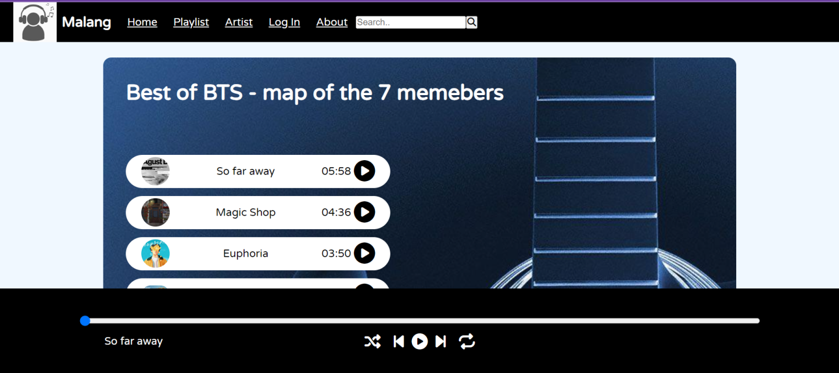

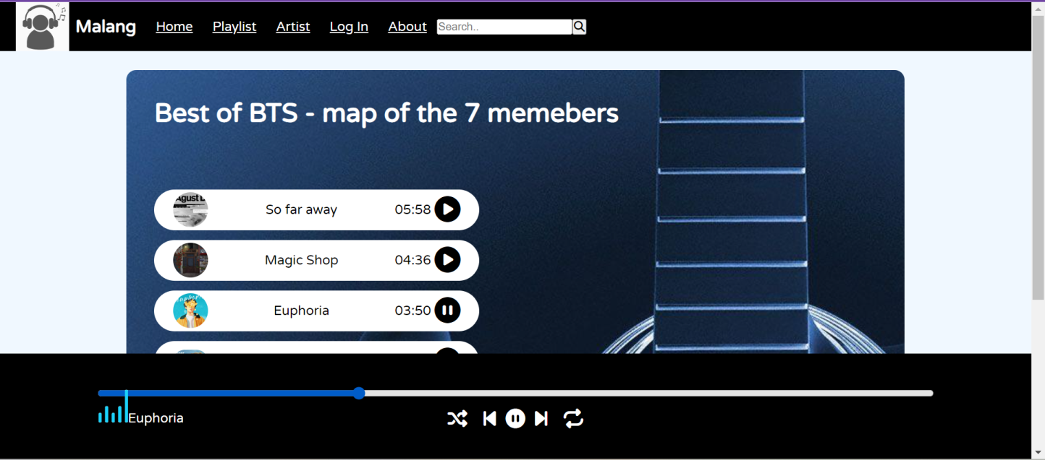

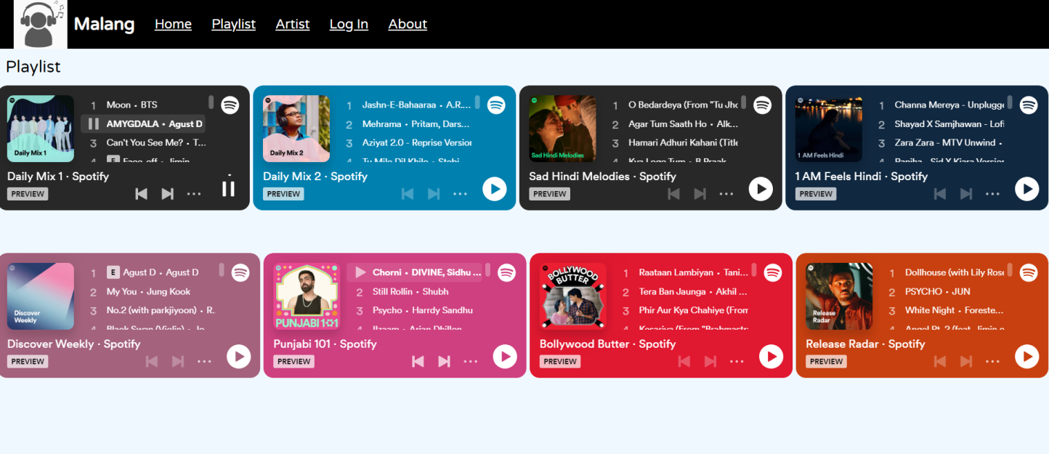

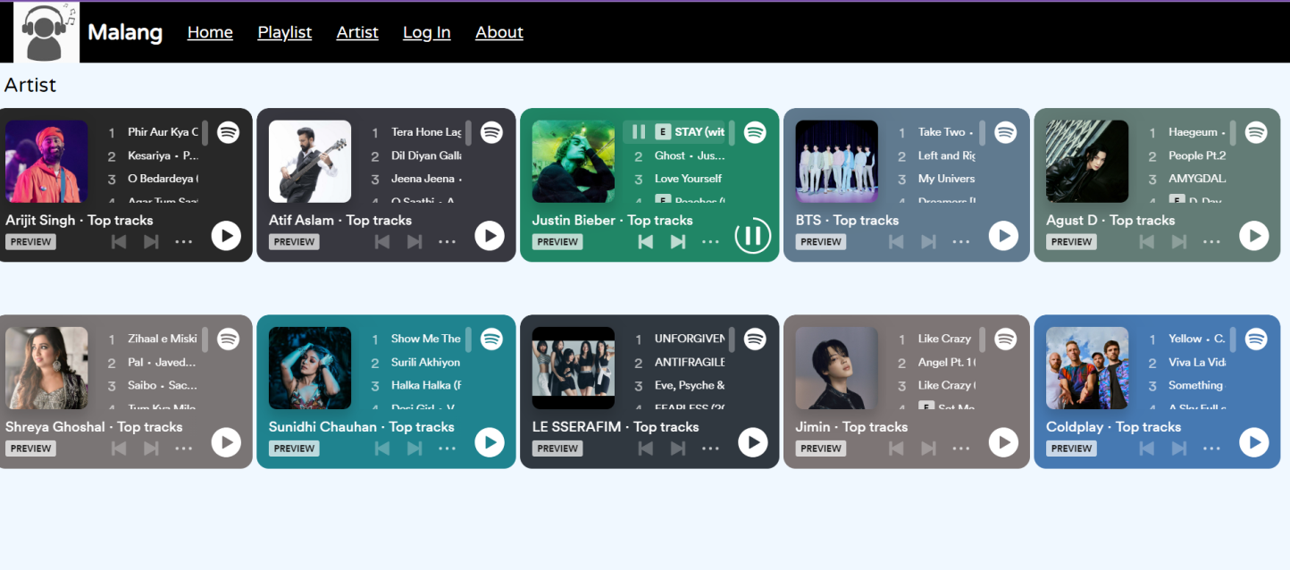

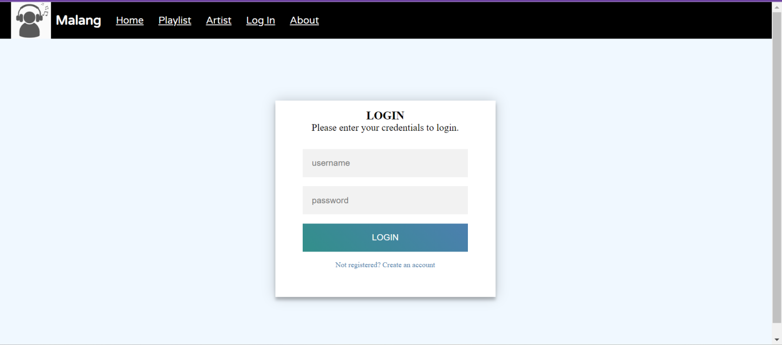

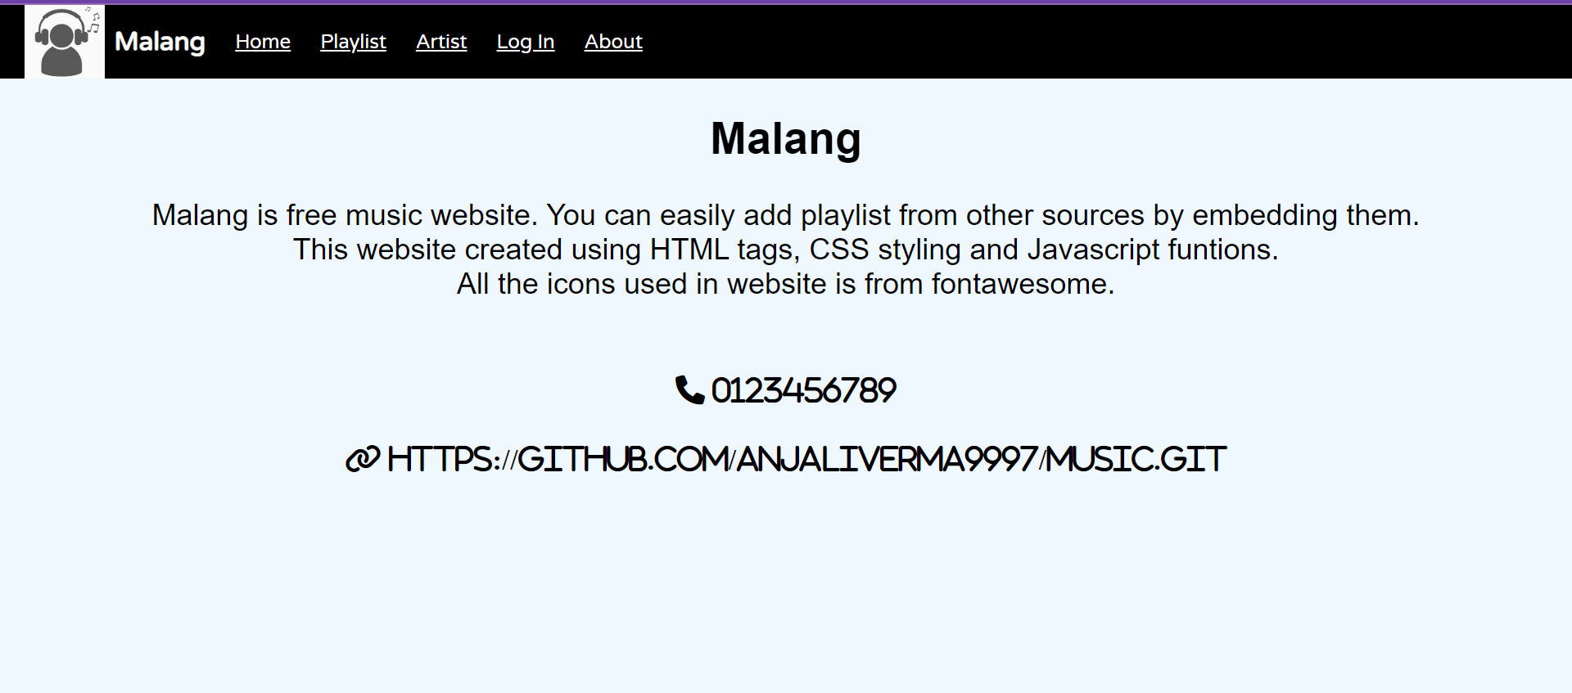

# Performance Test

## About Music Player Application

I named my project as **Malang** which means someone who doesn’t much care about his surroundings. I started working on project by creating it’s interface first for which I start with design part on application. All the design is done using HTML tags. I used icons in my project which is from fontawesome website which provide wide variety of icons. Next step was to style my website for which I use CSS styling code. After my user interface was completed I started working into functioning part of my project using javascript like on play song or previous and next button for song change. All coding of project is done in VS code as it easy to create one application in single folder and can be easily publish on github with provided extensions.

* **Home**

This page consist of top navigation bar which show all links to go from one page to another. There is one playlist already creating using html and javascript. The playlist songs and covers are all downloaded and included in separate folders. At footer another container is used for displaying which song is playing with it various buttons like shuffle, previous, play, next, repeat is shown. There is also range bar which show how much song is played and also allow to shift song to specific part.

* **Playlist**

This page consist of various playlist which are simply embedded from spotify. The playlist shows the preview of items in playlist and allow to play full song by importing to spotify.

* **Artist**

This page consist of various artists profile which is embedded from spotify. It show famous songs of artist and allow to play them by going to spotify.

* **Log In**

This page consist of log in form which is created using HTML form tag.

* **About**

This page simply consist of how website is created and github link is provided to view project.

## Test Plan/ Test Cases

After completing the project I tested it and music player pervious and next buttons are working well. Play song on play click is working good too when we want to pause song in middle the song stops. Progress bar can be use to slide song to favourite part which is working well too.

## Test Procedure

When the project is run on live server it open on home page which consist of already creating playlist. All songs in playlist have covers(.jpg) and songs(.mp3) which are downloaded from different sites and stored on different folders in project which makes it easy to manage. All songs included in playlist can be played. Navigation links makes easy to navigate to other pages on site. On playlist page, spotify allow to play preview of songs which then can be easily listened on spotify after clicking play on spotify which ask permission to allow spotify to open page. Same with artist page which direct to that artist spotify page. Log in form is for user account. About page gives how website is created and link is provided for github.

## Performance Outcome

Overall project is running well, song can be played, paused and can be changed through previous and next. Navigation of pages from one page to another is running well. But the shuffle and repeat buttons are not working as they should. I put search bar too so we can find song through it and I also created log in form so users can create there account but as timeline is near I’m not able to work on them further.

# Problem Statement

There’s lot of problems one project carry in my project there is to create music player which is functional with all it’s attributes.I have great difficulty to create function for each buttons like shuffle, previous, play, next, repeat which is solved by creating song array which works on index value given to item.

# Existing and Proposed solution

Existing solution is spotify but it started to charge premium for now playing one song on repeat or on loop. The proposed solution allows solution for this problem to play our favorite song on repeat.

## Code submission (Github link)

* <https://github.com/anjaliVerma9997/music.git>

## Report submission (Github link) :

# My learning’s

While creating this project I learned about the programming structures and logics. I used VS code for first time and I get to how it is easy to create application by putting everything in one folder. The Project I created needs to be uploaded on github which is again I used for first time it’s good way to upload our project and work on it, changes can be easily committed and others can check project too. I don’t know much about VS code and github before but through this internship I was able to learn something new like how projects are created and how they are uploaded and can be shared with another person in easy way. Through this internship I get to know how I have to learn more to become better developer.

# Future work scope

I want to create dynamic background in future for my site which will give good user experience . If there’s more time I should have added time range to see how much song is played. The site I created is not impressive which I agree but it is first time I created project on my own and I get to know lot of new things which will help me future to create more projects with better understanding.

# References

This project created from reference through:-

* Google –
* <https://r.search.yahoo.com/_ylt=AwrKDrtIbq5kfsQOWim7HAx.;_ylu=Y29sbwNzZzMEcG9zAzIEdnRpZAMEc2VjA3Ny/RV=2/RE=1689181896/RO=10/RU=https%3a%2f%2fdeveloper.mozilla.org%2fen-US%2f/RK=2/RS=EXwstZjukq6maBG8dD0XUT25AGI->
* <https://r.search.yahoo.com/_ylt=AwrKB0L8bq5kGWsNeZW7HAx.;_ylu=Y29sbwNzZzMEcG9zAzEEdnRpZAMEc2VjA3Ny/RV=2/RE=1689182077/RO=10/RU=https%3a%2f%2fwww.w3schools.com%2f/RK=2/RS=FkEIj3CgIe1AcLBmXwQelFD2T4k->
* YouTube –
* <https://www.youtube.com/watch?v=ANzPM5-lwXc&pp=ygUec3BvdGlmeSBjbG9uZSBjb2RlIHdpdGggaGFycnkg>